Building of the replica of medieval tread-wheel crane for the Castle of Tocnik in Central Bohemia

1. Identification data

Project: Replica of medieval wooden crane from the period of years 1390-1400 as a part of the exhibition “Charles IV – emperor by the grace of God”
Location: The City of Prague – Prague Castle, Synagogue in Prague - Liben
Date: 02-20-06 – 10-01-06
Organizers: Management of the Prague Castle, National Technical Museum (Prague)
Authors of the project: Petr Růžička, Ing. Vít Mlázovský
Contractor: Ars Tignaria spol. s r. o., Světova 19/133, 180 00 Praha 8, Czech Republic
Designer: Ing. Vít Mlázovský, Jánský vršek 4, 118 00 Praha 1, Czech Republic
Cooperation with: Ing. Marie Pilecká, Ing. Zdeněk Rieger
Financial support: ČSOB, a. s. (main partner)
Town of Hluboká nad Vltavou
Lesy ČR, s. p.
Lesy Hluboká nad Vltavou, a. s.
ASTRON Buildings S.A., Luxemburg
LinWorks, spol. s r. o.
Foto Škoda
Experts: Academy of Science of the Czech Republic, Institute of Theoretical and Applied Mechanics, ARCCHIP Centre of Excellence
Czech National Heritage Institute
Handshouse studio, Norwell, Maine, USA

2. Intentions and objectives

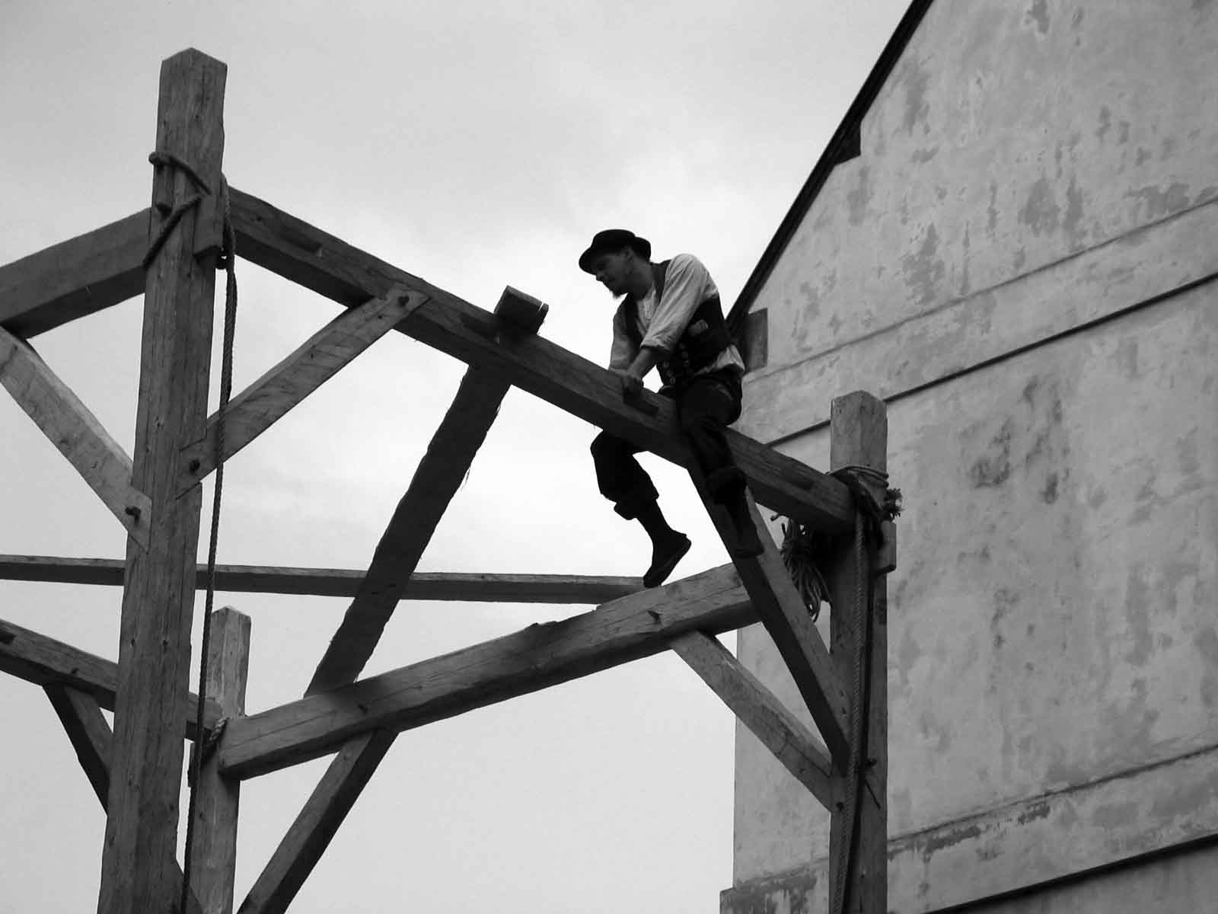
Authors intent to built a replica of a medieval crane operated by human force as a part of the exhibition “Charles IV – emperor by the grace of God”, which will be installed at the Prague Castle from February until May 2006. The crane is designed as a reconstruction according to pictures in the Bible of Wenceslas IV (1390-1400) and knowledge obtained during a research on preserved European tread-wheels (locations: Karlštejn, Schwäbisch Gmünd, Strasbourg, Beauvais). The construction works will be performed by medieval technologies, using the hand-crafted wood, and are open to public in Prague Castle and in the Synagogue in Prague – Libeň.
The event objectives are to demonstrate a forgotten construction skill of our ancestors, applied on a real functional object, and by means of that to motivate the interest of public in cultural heritage.
3. Broader context

The exhibition “Charles IV – emperor by the grace of God” dedicated to the art of the last generation of the Luxemburg dynasty, i.e. Charles IV, Wenceslas IV and Sigismund (www.hrad.cz; www.karel-IV.cz) contains more than 160 precious medieval masterpieces, provided by collection from Czech Republic, Slovakia, USA, Austria, Germany, Italy, Belgium, Great Britain and other countries.
The crane presentation on the exhibition in Prague is a part of a technical-historical experiment of “Using a wooden construction crane operated by human force in contemporary construction procedures“. After the exhibition, the crane will be used under conditions of practicable construction for truss repair works in the Royal palace of the Tocnik Castle, where the crane will be finally installed.
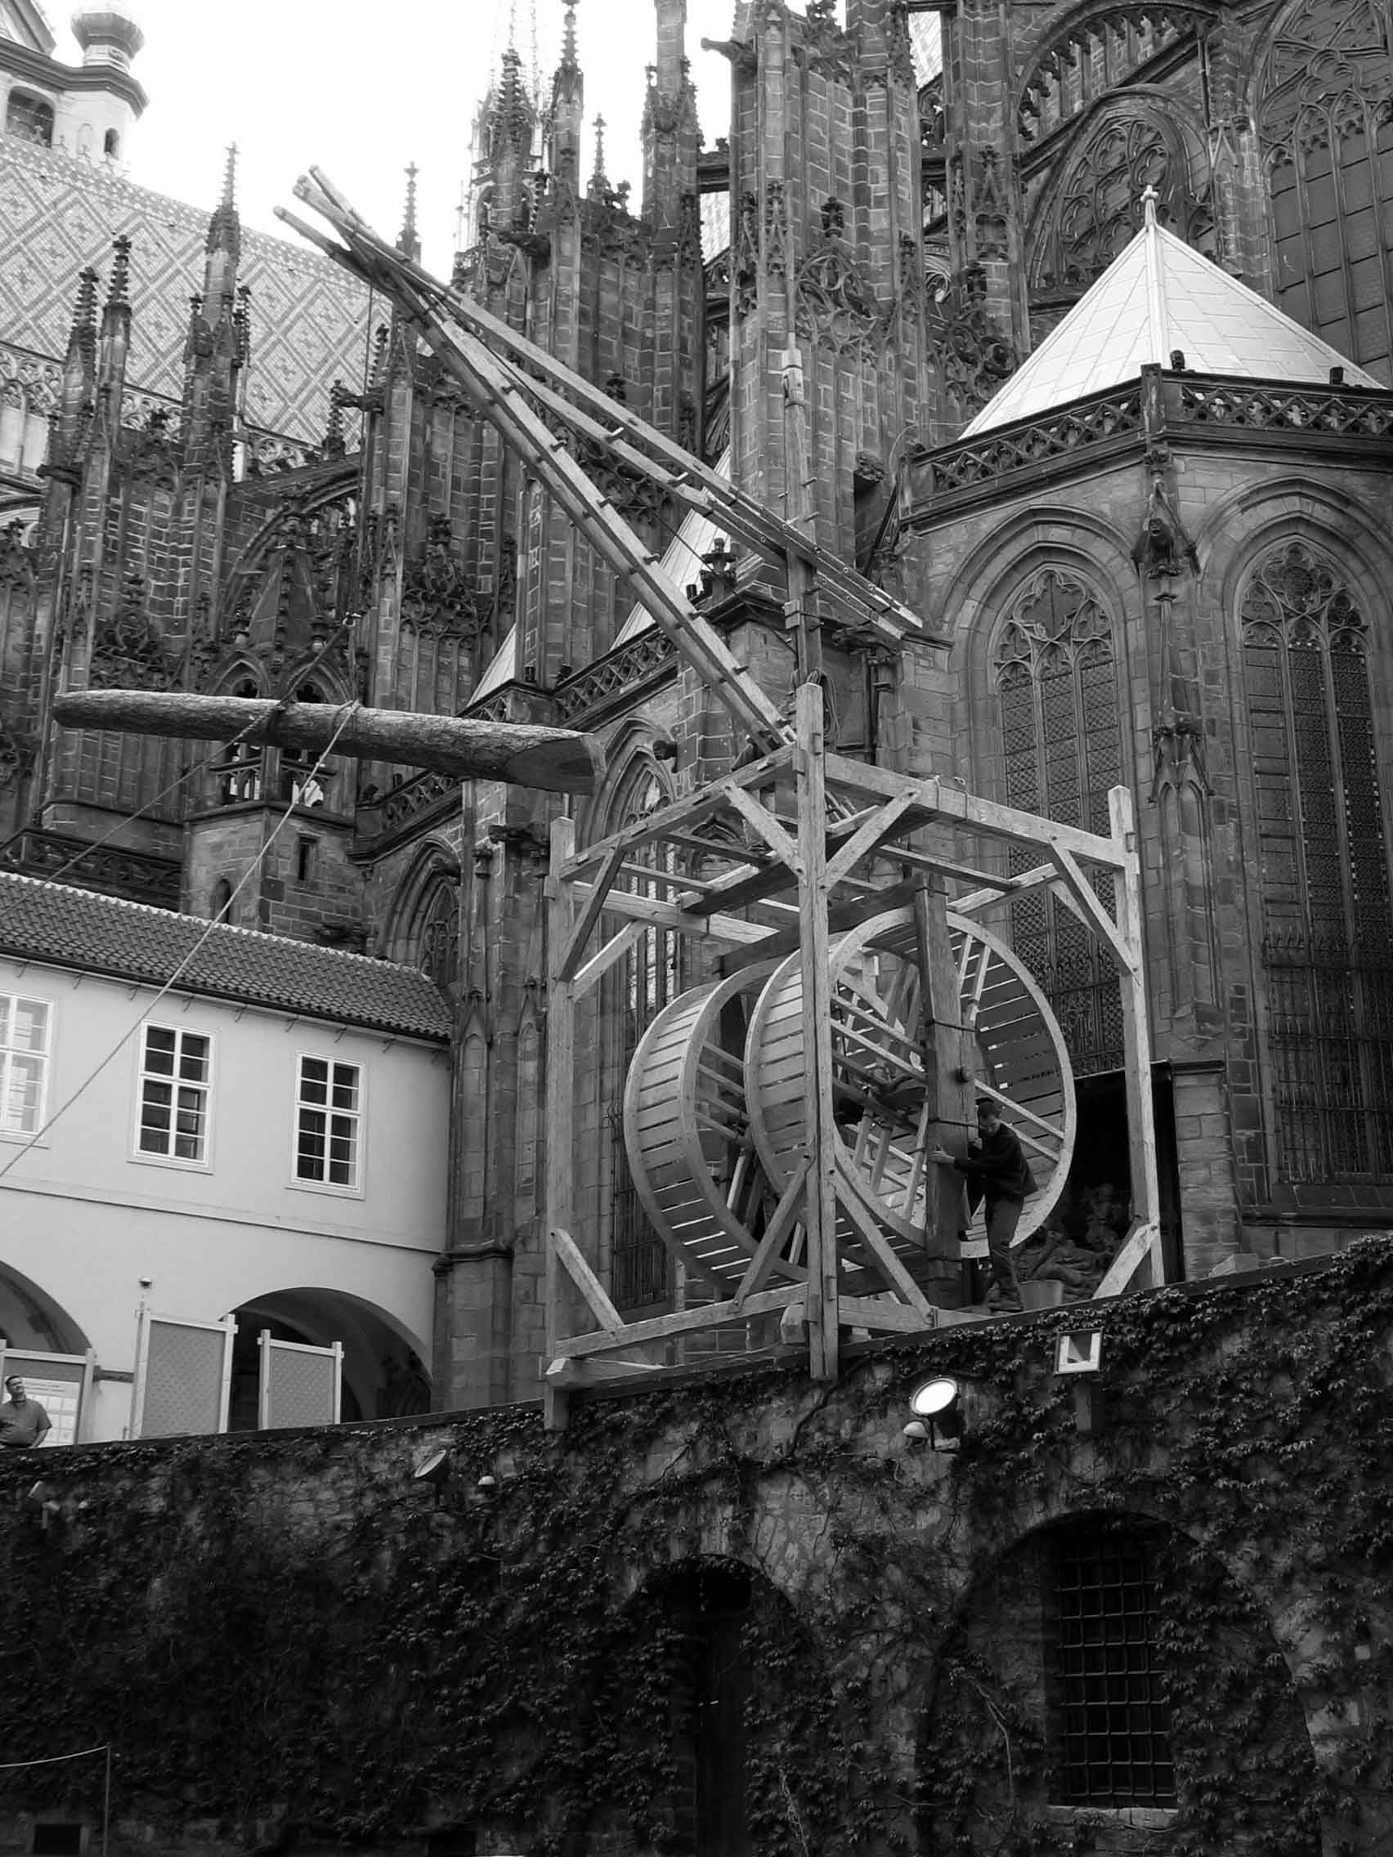
We have been brought to the idea of using the wooden crane operated by human force according to our recurrent experience with transporting of oversized loads to medieval castles. Their courtyards are often inaccessible for modern heavy transport vehicles and for that reason the transport of necessary objects makes usually the essential part of total construction budget. The historical transport technology is very easy to use and probably very profitable for the roof truss repair works at the Tocnik Castle. The ecological and energetic aspects attract our attention to these machines, which work on the base of fundamental mechanics. We assume that the application of such machines could bring essential benefit even today.
The objectives of this experiment are to verify the verity of historical iconographical sources, to check the technical parameters of the machine, to compare the productivity, production and energy costs, ecological impacts with modern construction mechanization and research of usability of these simple machines, operated by human force, in contemporary construction procedures. The designer has already successful experience with using replicas of historic wooden tools for the construction of a wooden bridge at the Krakovec Castle and for lifting of a new bell into the bell tower in Sázava Monastery (both in Central Bohemia).
We would like to kickoff the common pan-European effort to save the traditional carpenter craft arts; therefore we have invited carpenters and blacksmiths from abroad to this event. Our partners from Massachusetts College of Art in Boston, U.S., Laura and Rick Brown will help us with testing the function and the correct parameters of the tread-wheel. Together with their students they have already constructed a functional replica of the Perronet baroque crane from the year 1750. Teachers and students of Czech technical and art colleges will participate in the event, as well. The event is performed in cooperation with the Academy of Sciences of Czech Republic and the National Heritage Institute.
We have performed background researches of similar activities in Europe and USA and we can certify that there was no such event of this extent in the past. Several tread-wheel cranes have been constructed, but they were assembled by modern technology. These cranes were never used on common construction site and mostly they are only partially functioning models.

4. Technical parameters of the crane
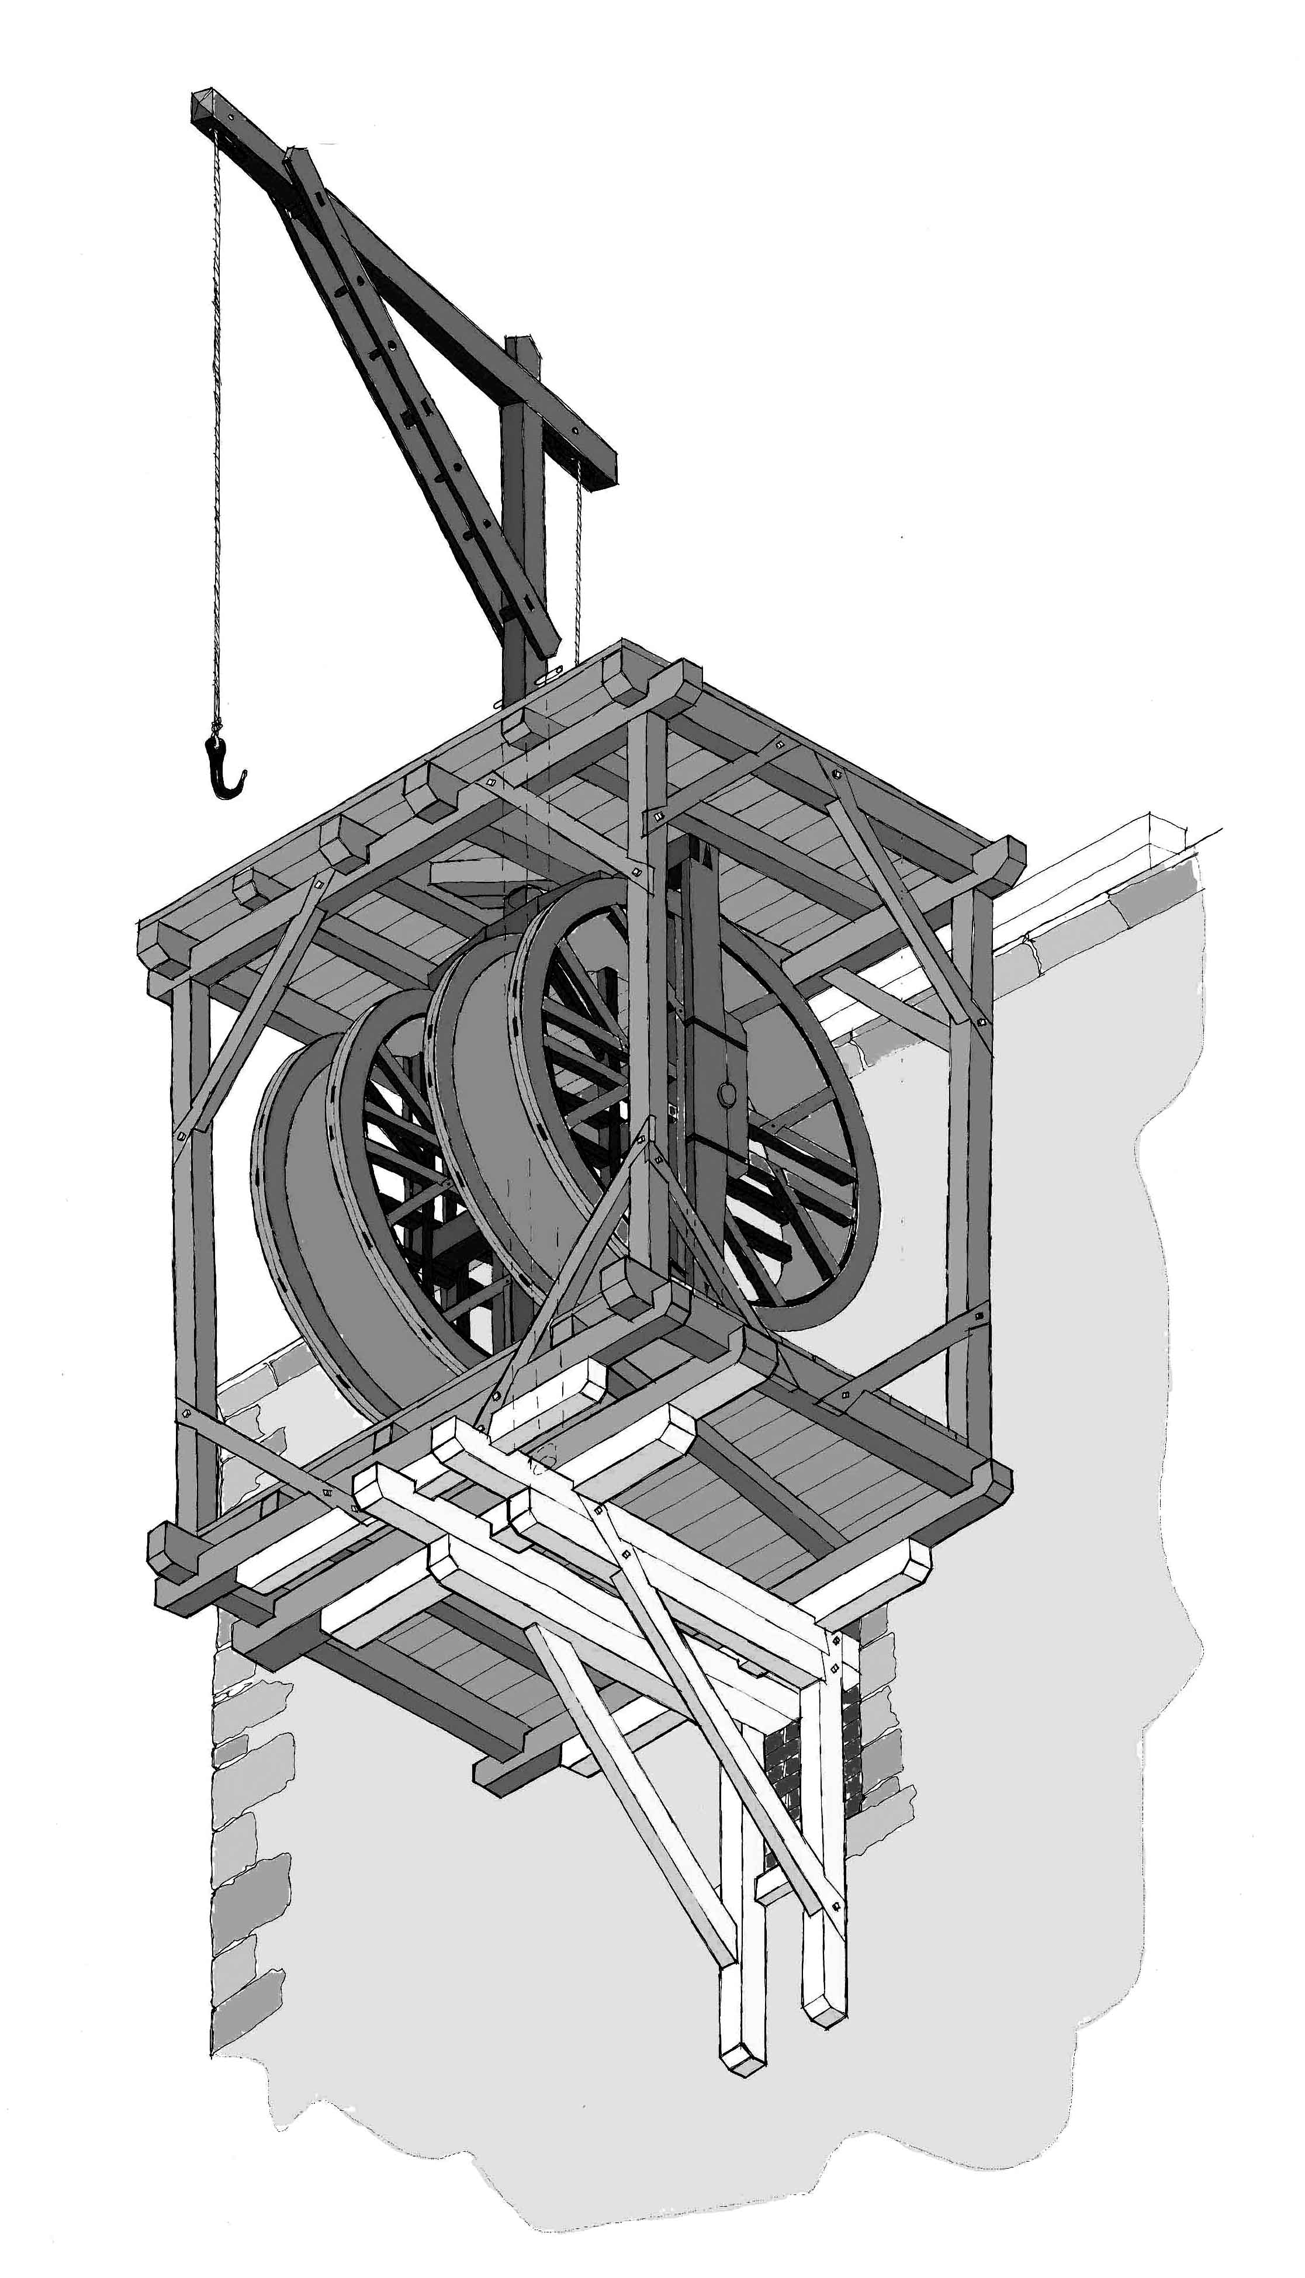
Ground plan of the cage 3.50 m × 3.50 m
Pole length 8.0 m (with footstall 9.0 m)
Radius of the lever arm 2.90 m – 4.70 m
Crane weight without operators and ballast 3 000 kg
Max. weight of burden 700 kg

5. Activities

- Project planning phase – The project documentary of the crane construction, performed in the Točník Castle, is already elaborated. The documentary needed some modifications in case of the crane installation in Prague Castle. These modifications deal with the cage and its fundament, static calculation and possibly a documentation of the machine presentation. The client receives the project documentation including the static calculations and the machine operation manual.

- Approval procedures and contracts – The crane presentation in the Prague Castle was consulted in Construction section of the Municipal council of the Capital City of Prague. The municipal council has the opinion that the event is no building construction, therefore no permission or notification is necessary. If the client needs a written statement in this matter, it is possible to notify the authority about the planned event. The created documentation is sufficient for this purpose. The event will be performed due to a contract between the client, designer and the contractor. The contract defines the responsibilities of individual contract parties. The client receives the final functional crane, with declaration written by the designer, proving that the product matches valid legal regulations and with a declaration written by the project contractor proving, that the product matches the project documentation. Client’s employees will be trained by the contractor to operate the machine. The training activities will be recorded in a written form.

- Material preparation – Timbers will be crafted manually, planks and boards will be sewed by frame tractive saw, and the form of the wheel will be chopped from round timbers. The material preparation will be consistently carried out by medieval technologies, which were reconstructed on the base of iconographical sources studies, where replicas of historical tools will be used. The main part of the preparation will be carried out in location of Prague Castle, which can be free accessed by public. Location rental of the Synagogue in Libeň has been negotiated. In this location we have already performed the arch construction (object of the ARCHA Theater) and the arbor construction, which was used for presentation of Czech Republic in exhibition FLORIADA 2002 in Amsterdam. In Prague Castle (on the Northern yard) we will perform only some elements of construction procedures to present the utilization of medieval technologies and tools to public. The chopping and sewing presentation will be preformed in the Northern yard on a protection floor, assembled from oriented stand boards of 7×15 m size. Selected timbers of 4,0 m length will be transported by 3.5 t transport vehicle and by manually operated barrows with pneumatic wheels to be able to pass the passage access to the Northern yard.
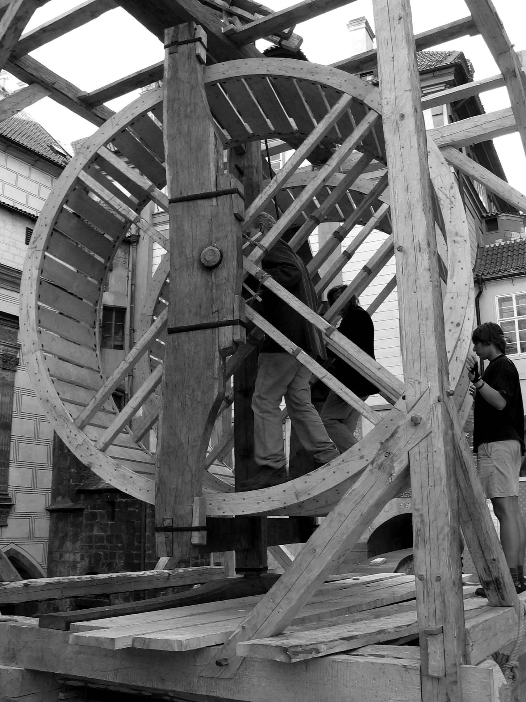
- Construction measurement will be performed in public in the working floor located in the Synagogue, in scale 1:1, using the circle method, which has been worked out according to the iconographic sources (sketchbook of Villard de Honnecourt and mural painting “Apparition of St. John” from the apocalyptic cycle in the Church of Our Lady at the Karlstejn Castle).

- Production – The construction will be connected by classic craft joints, chopped manually, using hand tools. Most of the joint parts are wooden (pegs, dowel pins, chocks). The metal joint parts (wheel fame stirrup, pulley axis, nails in the form) will be forged. We assume that the main part of the production will be performed in the Northern yard. The material transport from the Synagogue to the Northern yard is described in the point no. 3. It includes the longest part of 0.8 m length and 300 kg weight.

- Assembly – The construction will be completely assembled in the location of Prague Castle. For the assembly we will use wooden contrivances, which has been assembled in similar way (hoist, small ladder crane) and supporting construction (carpenter saw horses, assembly bench). The crane raise up will be a part of an international carpenter workshop with invited audience from many countries. It is essential to close the Northern yard for public during the assembly works. It is possible to keep free the passage to the exhibition “The Story of Prague Castle“.

6. Work Schedule
Activity: | From: | Until: | Location:
Oakwood felling with axes | 02-20-06 | 03-03-06 | Hluboká nad Vltavou
Material preparation and timber hewing | 03-06-06 | 03-31-06 | Palmovka Synagogue
Crane elaboration | 04-03-06 | 04-28-06 | Prague Castle
Crane assemblage and testing (workshop) | 05-01-06 | 05-07-06 | Prague Castle
Crane work demonstrations | 05-01-06 | 09-30-06 | Prague Castle

7. Prague Castle situation plan

